Created on: 4/6/05
Topic: Star Clusters & Binary Star Systems

- Star clusters
  - Star clusters – Large population of stars
  - Prove theories
  - O, B, and A from the Main sequence are missing
    - Stars that died early are missing
    - Example:
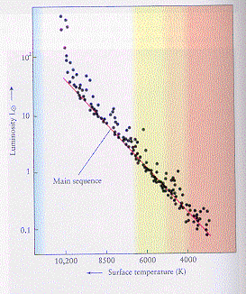
  - Main Sequence Turnoff
    - You figure out the age of a star cluster from the position of the Main Sequence Turnoff
      - Later (Right) = Older (Globular Star Cluster)
      - Earlier (Left) = Younger (Open Star Cluster)
  - Asymptotic Giant Branch
    - Red giant stage
  - Horizontal Branch
    - ?
  - Clump
    - Stars in helium burning phase
  - We need the temperature and luminosity (aka absolute magnitude, but we need the distance to find this) to plot a star on the diagram
  - Since all of the stars in a star cluster are the same distance from us, but some stars are brighter than others, it means that the stars that are brighter are actually brighter (not brighter based on distance from the star) (absolute magnitude = actual brightness)
  - Main sequence fitting – next rung of the cosmological distance ladder
    - Works up to 10,000 (10 kilo) parsecs (just to the edge of the Milky Way Galaxy)
    - Slide star cluster diagram up or down until the Main Sequence is where it belongs
- Binary star systems
  - Most star system are binary in the solar neighborhood
  - Binary star systems happen when a star is forming and it breaks into two stars which end up orbiting one another
    - Reason why low mass stars are so common
  - Our star system (Solar System) is a single-star star system
  - Alpha-Centuri C is the closest star in the closest star system to Sun
  - 2 low mass stars
    - Stars evolve independently from one another IF they are far enough away from one another
    - If stars are close to one another, one star will die before another (since stars don’t have exactly equal mass)
      - As one star (1) becomes a red giant, the other star (2) will pull material from the red giant towards it
      - The material will spin and will eventually crash into star 2, and become part of the low mass star, decreasing the star’s lifetime
      - The star could evolve off of the Main Sequence prematurely, causing it to become a red giant
      - The white dwarf core (1) will have material floating around it (from 2)
  - 1 high mass and 1 low mass star
    - Material from high mass star will go to the low mass star (aka primary star)
    - The supernova explosion from the high mass star (secondary star/compact object) will NOT disrupt the low mass star
    - Material from the dying low mass star will float around the neutron star OR black hole and radiate x-rays. These are known as X-ray Binaries
      - X-ray bursts will come from neutron stars
      - Black holes do not have any x-ray bursts

